EQUALSPACE: COMPREHENSIVE OVERVIEW

1. What is EqualSpace?
EqualSpace is a slow-dating platform engineered specifically for introverts, thoughtful communicators, and high-intent daters. Unlike traditional swiping apps that maximize continuous screen time and superficial swiping, EqualSpace introduces intentional friction, structured pacing, and strict capacity controls to create a balanced, respectful, and burnout-free matchmaking environment.

2. The Core Problems with Modern Dating Apps
Severe Gender Imbalance: Dating apps in urban markets often reach up to 74% male and 26% female participation, leading to extreme competition for men and cognitive overload for women.
Inbox Saturation & Cognitive Fatigue: Unfiltered inbound messages flood women with low-effort opening lines, forcing them to adopt harsh visual filtering heuristics.
Low Intent & Swiping Burnout: Unconstrained swiping mechanisms encourage high-volume, low-effort interactions, driving interaction drop-offs and platform fatigue.

3. The EqualSpace Unique Mechanics
- 1:1 Regional Active Gender Parity: Maintains an exact 1:1 active gender ratio per city. When male slots fill up, new male users enter a queue until female slots become available.
- Mandatory eKYC & Intent Gate: Requires DigiLocker Aadhaar eKYC verification and a slot entry fee to eliminate bots, catfish, and low-intent participants.
- 72-Hour Active Windows & 14-Day Cooldowns: Users operate in focused 72-hour active discovery windows followed by a mandatory 14-day rotational cooldown to reduce burnout.
- Maximum 5 Concurrent Active Chats: Limits concurrent active chats to 5 at a time, ensuring genuine focus and depth in conversation.
- Dynamic Living Boundaries & AI Wingman: Models communication speed, real-time energy levels, and emotional pacing, warning users before chat unlock if pacing styles diverge.
- Dual Matching Engine: Combines a daily batch push of 3–5 hyper-compatible recommendations with Thoughtline—an anonymous, lightweight social feed featuring an intelligent Top 10–12 compatibility filter for overwhelm protection.
- List 1: Daily Curated Algorithmic Push: Every morning at 8:00 AM, the system sends 3 to 5 deeply compatible profile picks directly to the user. Users review these curated recommendations without the noise of endless swiping.
- List 2: Thoughtline Social Feed (Pull Engine) & Overwhelm Protection: An anonymous, text-first micro-feed where users post thoughts and organic ideas without public comment sections. When a post receives more than 12 likes, the Top 10–12 Compatibility Filter automatically ranks incoming match offers by compatibility score and surfaces only the top 10–12 profiles to the author. Additional match offers are held safely in a queue and dynamically backfilled as the author acts on profiles, preventing inbox fatigue and burnout.
- 5-Question Contextual Icebreaker Quiz: Replaces generic "hey" messages with a structured 5-question alignment quiz that reveals shared perspectives before unlocking direct messaging.

EqualSpace (v1.0) Product & Engineering Specification Document

SECTION 1: EXECUTIVE SUMMARY & CORE PHILOSOPHY

Structural Crisis in Modern Digital Matchmaking
The modern online matchmaking industry suffers from a fundamental structural asymmetry that degrades user experience across all demographics. Contemporary swipe-based dating platforms operate on unconstrained liquidity models that exacerbate gender imbalances and encourage high-volume, low-intent interactions. In major urban centers, demographic imbalances reach up to 74% male to 26% female participation. This hyper-asymmetric distribution triggers severe market externalities that cascade across the ecosystem.

Market Externality Phase | Underlying Structural Cause | Resulting Behavioral Impact | Platform Feedback Loop
1. Male Over-Supply | Uncapped registration and regional liquidity models. | High competition for visibility among male users. | Men shift to automated or high-frequency swiping strategies.
2. Female Saturation | Unfiltered inbound interaction channels. | Inbox saturation, severe cognitive fatigue, and low-effort "hey" spam. | Women adopt defensive, hyper-selective visual filters.
3. Male Invisibility | Algorithmic deprioritization due to low match ratios. | Match rates drop below viability thresholds. | Acceleration of swiping volume to counter algorithmic drop.
4. Systemic Burnout | Asynchronous communication pressure and low intent. | High interaction drop-off and ambient stress. | Platform churn and abandonment across all demographics.

The EqualSpace Solution
EqualSpace (v1.0) is designed as a gated, low-latency, slow-dating platform engineered specifically for introverts, overthinkers, and high-intent daters. Rather than maximizing daily active time or continuous swiping sessions, EqualSpace enforces structural constraints, paced interaction mechanics, and deep multi-layered psychographic matching. The system implements strict city-level 1:1 active gender quotas, mandatory Aadhaar/DigiLocker eKYC verification, slot booking fees, 72-hour active windows, a maximum of 5 concurrent active chats, and mandatory 14-day rotational cooldowns.

Core Tagline
"Permission to speak before pressure to perform."

Operational Principles
- Symmetrical Attention Allocation: Ensuring every active participant receives visibility proportional to their intent rather than their platform activity volume.
- Friction as Value: Integrating intentional friction points—such as mandatory identity verification fees, multi-question unlock quizzes, and active window cooldowns—to filter out bots, catfish, and low-intent participants.
- Contextual Boundary Awareness: Explicitly modeling user communication speed, emotional battery states, and relationship pacing directly within the matching runtime prior to facilitating chat unlock.
- Controlled System Liquidity: Maintaining strict system balance through active pool capacity caps, preventing the network effects that lead to inbox saturation.

SECTION 2: DEEP PSYCHOGRAPHIC & BOUNDARY PROFILING LAYER

Mandatory Onboarding & Profile Parameter Matrix Table

Attribute Group | Field Name | Data Type / Format | Validation / Constraints | Operational Purpose
Core Identity | full_legal_name | String (VarChar 150) | Match with DigiLocker eKYC | KYC verification and record mapping
Core Identity | date_of_birth | Date (YYYY-MM-DD) | Age >= 18; Verified via KYC | Age restriction; Numerology calculations
Core Identity | time_of_birth | Time (HH:MM:SS) | Optional / User input | Precision astrology calculation (Rising sign)
Core Identity | place_of_birth | JSON Object | Geo-coordinates (Lat/Long) | Precision astrology natal chart calculation
Psychographics | mbti_type | Enum (16 Types) | Valid MBTI String (e.g., INFJ) | Primary cognitive complementarity scoring
Psychographics | mbti_functions | JSON Object | 4 Function Array (Dominant to Inferior) | Deep cognitive vector distance evaluation
Psychographics | sun_sign | Enum (12 Signs) | Auto-derived from DOB | Elemental synastry calculation
Psychographics | moon_sign | Enum (12 Signs) | Auto-derived from DOB + Time | Emotional compatibility calculation
Psychographics | rising_sign | Enum (12 Signs) | Auto-derived from DOB + Time + Location | Social persona / interaction alignment
Psychographics | life_path_number | SmallInt (1-9, 11, 22, 33) | Auto-derived from DOB digits | Esoteric affinity scoring
Living Boundaries | reply_speed_pref | Enum | 4 discrete states | Communication expectations alignment
Living Boundaries | social_energy_state | Enum | 5 discrete states | Real-time interaction filtering
Living Boundaries | emotional_pacing | Enum | 4 discrete states | Conversation style matching

Dynamic Living Boundaries Architecture
Dynamic Living Boundaries are state-driven configurations managed by the user that modulate match availability and surface real-time interaction constraints:
- 1. Reply Speed Preferences (reply_speed_pref): Defines expected cadence for asynchronous communication. Options: immediate (real-time synchronous sessions), balanced_async (responses within 2–4 hours), slow_replies_preferred (low-pressure exchanges with 12–24 hour response times), batch_responder (responds once or twice daily at dedicated times).
- 2. Social Energy State & Battery Meters (social_energy_state): A real-time state variable mapped to a numerical battery percentage. Options: high_energy (81–100%), moderate_social (51–80%), low_battery_today (26–50%), quiet_today (11–25%), deep_talks_only (0–10%).
- 3. Emotional Pacing Controls (emotional_pacing): Defines initial conversation progression. Options: no_flirting_too_early (enforces intellectual/platonic focus prior to romantic expressions), platonic_first (establishes baseline shared interests first), conversational_pacing_slow (steady, multi-day exchanges before offline meetings), intent_driven_direct (clear evaluation of values and alignment early on).

AI Wingman & Boundary Awareness Engine
The AI Wingman is an asynchronous conflict-detection sub-system executing pre-match and pre-chat evaluation routines. When two user profiles achieve structural compatibility, the engine computes a Boundary Conflict Score (S_b):
S_b = δ(reply_speed) + δ(social_energy) + δ(emotional_pacing)
Where δ represents a calibrated numerical distance scalar between boundary states, normalized between 0.0 and 1.0. The platform sets the conflict threshold S_threshold = 0.65.

Boundary Field | Candidate A State | Candidate B State | Parameter Delta (δ) | Conflict Description
reply_speed_pref | immediate | slow_replies_preferred | 0.85 | High cadence mismatch; risk of response anxiety.
social_energy_state | high_energy (90%) | low_battery_today (30%) | 0.60 | Energy volume imbalance; potential fatigue.
emotional_pacing | intent_driven_direct | no_flirting_too_early | 0.75 | Pacing divergence; risk of premature romantic pressure.
When S_b >= S_threshold, the system triggers a Boundary Awareness Surface displaying contextual overlays:
- Trigger Sequence: User A (immediate / intent_driven_direct) matches with User B (slow_replies_preferred / no_flirting_too_early).
- System Action: Generates Boundary Awareness Surface to both users before chat unlock. User A is notified: "User B prefers reflective, slow-paced exchanges and low-pressure conversations. Immediate replies are not expected." User B is notified: "User A prefers direct, high-intent communication. They have been informed of your preferred response cadence."
- Mitigation Enforcement: Disables aggressive dynamic push notifications for User B and caps message send rates for User A until mutual baseline interaction metrics are satisfied.

SECTION 3: SYSTEM ARCHITECTURE & DATABASE SCHEMA (PostgreSQL / JSONB)

1. users_profile Table

Column Name | Data Type | Constraints / Keys | Description
user_id | UUID | Primary Key, DEFAULT gen_random_uuid() | Unique immutable profile identifier
phone_number | VARCHAR(15) | Unique, Not Null | E.164 format primary user identifier
kyc_status | ENUM | Not Null, Default: 'pending' | Values: 'pending', 'verified', 'failed', 'rejected'
digilocker_ref_id | VARCHAR(100) | Unique, Nullable | Anonymized reference hash from DigiLocker API
masked_aadhaar | VARCHAR(12) | Nullable | Masked Aadhaar number (e.g., XXXX-XXXX-1234)
verified_name | VARCHAR(150) | Nullable | Full legal name retrieved from verified eKYC XML
verified_dob | DATE | Nullable | Verified date of birth from government ID
gender | ENUM | Not Null | Values: 'male', 'female', 'non_binary'
city_partition | VARCHAR(50) | Not Null, Indexed | Regional partitioning key (e.g., 'IN-BLR-01')
mbti_type | VARCHAR(4) | Not Null | 4-letter Myers-Briggs string indicator
mbti_functions | JSONB | Not Null | Structured array of cognitive functions
astrology_data | JSONB | Not Null | JSON containing Sun, Moon, and Rising sign data
numerology_data | JSONB | Not Null | JSON containing Life Path and core numbers
dynamic_boundaries | JSONB | Not Null | Living boundary state JSON payload
created_at | TIMESTAMPTZ | Not Null, Default: NOW() | System record creation timestamp
updated_at | TIMESTAMPTZ | Not Null, Default: NOW() | Record last modification timestamp
Exact JSON Payload Structure for dynamic_boundaries:

{
"reply_speed_pref": "slow_replies_preferred",
"social_energy_state": "low_battery_today",
"social_battery_pct": 35,
"emotional_pacing": "no_flirting_too_early",
"last_updated": "2026-10-31T01:15:00Z"
}

2. active_pool_slots Table
Manages Layer 2 regional capacity quotas, 72-hour active interaction windows, entry fees, and mandatory 14-day rotational cooldowns.

Column Name | Data Type | Constraints / Keys | Description
slot_id | UUID | Primary Key, DEFAULT gen_random_uuid() | Unique active slot record identifier
user_id | UUID | Foreign Key (users_profile.user_id), Unique | Reference to verified user profile
city_partition | VARCHAR(50) | Not Null, Indexed | Regional capacity partition code
gender | ENUM | Not Null | Enforces regional 1:1 parity checks
pool_status | ENUM | Not Null, Default: 'queued' | Values: 'queued', 'active', 'cooldown', 'archived'
window_start_time | TIMESTAMPTZ | Nullable | Timestamp when 72-hour active window opened
window_expires_at | TIMESTAMPTZ | Nullable, Indexed | Timestamp when 72-hour active window expires
active_chat_count | SMALLINT | Not Null, Default: 0, Check <= 5 | Current active concurrent chats (Max 5)
booking_fee_txn_id | VARCHAR(100) | Nullable | Payment Gateway Transaction ID for slot fee
cooldown_until | TIMESTAMPTZ | Nullable, Indexed | End timestamp for mandatory 14-day cooldown
created_at | TIMESTAMPTZ | Not Null, Default: NOW() | Queue entry creation timestamp

3. thoughtline_posts Table
Powers the anonymous, lightweight Thoughtline social micro-feed. Enforces hard publication limits and disables public comments.

Column Name | Data Type | Constraints / Keys | Description
post_id | UUID | Primary Key, DEFAULT gen_random_uuid() | Unique post publication identifier
author_id | UUID | Foreign Key (users_profile.user_id), Not Null | Reference to publishing user
city_partition | VARCHAR(50) | Not Null, Indexed | Partition key for localized feed delivery
content_text | VARCHAR(280) | Not Null | Text payload limited to 280 characters
post_date | DATE | Not Null, Default: CURRENT_DATE | Date key used to enforce max 2 posts/day
comments_disabled | BOOLEAN | Not Null, Default: TRUE | Hard constraint: public comments permanently disabled
like_count | INTEGER | Not Null, Default: 0 | Aggregate count of received match offers
is_active | BOOLEAN | Not Null, Default: TRUE | Soft deletion/expiration state flag
created_at | TIMESTAMPTZ | Not Null, Default: NOW() | Publication creation timestamp

4. post_likes Table
Tracks private match offers generated via Thoughtline posts, along with algorithmic compatibility scores and overwhelm protection status.

Column Name | Data Type | Constraints / Keys | Description
like_id | UUID | Primary Key, DEFAULT gen_random_uuid() | Unique match offer identifier
post_id | UUID | Foreign Key (thoughtline_posts.post_id), Not Null | Target post receiving the offer
liker_id | UUID | Foreign Key (users_profile.user_id), Not Null | User initiating the post-like match offer
compatibility_score | NUMERIC(5,2) | Not Null | Calculated compatibility index C_i (0 to 100)
review_status | ENUM | Not Null, Default: 'pending_review' | Values: 'pending_review', 'surfaced_top_12', 'approved', 'passed', 'expired'
rank_position | INTEGER | Nullable | Rank order in the post author's queue
created_at | TIMESTAMPTZ | Not Null, Default: NOW() | Match offer initiation timestamp

SECTION 4: THE TWO-LIST DUAL MATCHING ENGINE PIPELINES

Pipeline Dimension | List 1: Daily Curated Algorithmic Push | List 2: Thoughtline Social Feed (Pull Engine)
Delivery Model | Server-driven daily batch push payload. | Real-time asynchronous text feed discovery.
User Control | Passive reception of top 3–5 hyper-compatible picks. | Active publication (1–2 posts/day) and post-likes.
Interaction Target | Full psychographic profile evaluation. | Authentic micro-thoughts with disabled public comments.
Match Generation | Mutual confirmation on algorithmic selection. | "Like = Match Offer" submitted to post queue.
Overwhelm Protection | Hard cap of 3–5 candidate profiles per 24 hours. | Top 10–12 compatibility filtering when likes > 12.

Pipeline 1: List 1 - Daily Curated Algorithmic Push
- Cron Execution: Scheduled batch job executes at 06:00 AM local time per city_partition.
- Hard Constraint Filtering: Excludes candidates failing identity verification (kyc_status != 'verified'), location mismatch (city_partition mismatch), active blocks/passes/chat history within 90 days, or pool capacity violations (pool_status != 'active').
- Multi-Dimensional Compatibility Index Formula: Candidates passing hard filtering are scored via:
C_i = w_1 · S_MBTI + w_2 · S_Boundary + w_3 · S_Energy + w_4 · S_Esoteric
Where weights sum to 1.0: w_1 = 0.35, w_2 = 0.30, w_3 = 0.20, and w_4 = 0.15.
- MBTI Complementarity (S_MBTI): Calculated via cognitive function matrix alignment (0 to 100), pairing complementary stacks.
- Boundary & Pacing Match (S_Boundary): S_Boundary = 100 · (1.0 - S_b). Evaluates alignment between reply speed and emotional pacing.
- Social Energy Alignment (S_Energy): S_Energy = 100 - |Battery_UserA - Battery_UserB|. Measures delta between real-time battery levels (0 to 100).
- Esoteric Synastry Score (S_Esoteric): S_Esoteric = (0.6 · Elemental_Matrix) + (0.4 · LifePath_Affinity).
- Strict Delivery Volume: Exactly 3 to 5 picks sorted by C_i are written to Redis user cache buffers at 08:00 AM local time. No additional picks are provided until the next daily run.

Pipeline 2: List 2 - Thoughtline Social Feed & Post-Like Match Offer (Pull Engine)
- Feed Mechanics & Posting Caps: Users are restricted to 1 to 2 posts per day max. Public comments are disabled.
- Like = Match Offer Mechanism: Liking a post does not show a public counter; it submits a private match offer directly to the post author's review queue.
- Overwhelm Loophole Fix (Top 10–12 Compatibility Filter): When like_count > 12, the queue enters protection mode. System scores incoming likers via C_i and sets review_status = 'surfaced_top_12' for only the top 10 to 12 profiles, holding the rest in 'pending_review'.
- Dynamic Backfilling Logic: When the author approves or passes a surfaced candidate, the next highest candidate is auto-surfaced:
SELECT like_id FROM post_likes
WHERE post_id = :target_post AND review_status = 'pending_review'
ORDER BY compatibility_score DESC LIMIT 1;

SECTION 5: CAPACITY MANAGEMENT & THE 1:1 ACTIVE POOL SYSTEM

Layer 2 Capacity Enforcement Rules
EqualSpace maintains a strict 1:1 active gender ratio within any city_partition. If male entry requests exceed female active slots, male profiles enter a holding queue (pool_status = 'queued') until female slots open. Anonymous registrations are blocked; users must pass Aadhaar/DigiLocker eKYC and pay slot entry fees.

DigiLocker & Aadhaar eKYC Integration Architecture

Integration Step | Technical Protocol / Endpoint | Payload Parameters / Actions | Verification Outcome
1. Session Initiation | POST /tools/kyc/digilocker | Client ID, redirect_uri, code_challenge (S256). | Generates state token and DigiLocker URL.
2. Redirect & Consent | https://digilocker.meripehchaan.gov.in/public/oauth2/1/authorize | User logs in via Aadhaar OTP/PIN; approves e-Aadhaar scope. | DigiLocker issues authorization code.
3. Token Exchange | POST /oauth2/1/token | Exchange code + code_verifier on backend server. | Returns OAuth 2.0 Access Token & ID Token.
4. XML Retrieval | GET /file/issued/eaadhaar | Access token provided in Authorization header. | Pulls digitally signed e-Aadhaar XML file.
5. Parse & Validate | Internal Cryptographic Parsing | Parse Name, DOB, Gender, Masked Aadhaar, Address, Photo. | Validates signature; sets kyc_status = 'verified'.
The eKYC integration uses Meri Pehchaan API Spec v2.4 endpoints with PKCE (S256 code challenge). Cryptographic verification validates the digital signature on the XML payload and enforces Indian data residency requirements.

Active Window & Concurrent Chat Limits
Active pool access remains valid for 72 hours. Active chats are capped at 5 concurrent slots. Reaching 5 active chats pauses discovery feeds until slots open.

Rotational Exit & Cooldown State Machine
Upon window expiration (72 hours elapsed) or chat loop completion, profiles enter a mandatory 14-day rotational cooldown. Active chats from the expired window transition to read-only state and are archived upon starting a new window 14 days later.

SECTION 6: END-TO-END USER JOURNEY & CHAT UNLOCK FLOW

Detailed Chronological Step-by-Step Experience
- Step 1: Onboarding, Identity Verification, and Entry Fee: Phone OTP registration, DigiLocker Aadhaar eKYC, and booking fee payment.
- Step 2: Psychographic Matrix & Boundary Configuration: Birth parameters input, MBTI assessment, astrology/numerology derivation, and boundary selection.
- Step 3: Discovery Execution: Path A (List 1 daily batch push) or Path B (List 2 Thoughtline social feed offers).
- Step 4: Selection and Mutual Approval Trigger: Mutual interest established; direct messaging blocked.
- Step 5: The 5-Question Compatibility Unlock System: Asynchronous quiz room unlocks direct chat upon completion.

Question Sequence | Psychological Axis Evaluated | Contextual Focus & Sample Mechanics
Question 1 | Core Values & Social Energy | Selection of weekend energy preferences (Solitude vs. Social Gathering).
Question 2 | Communication Cadence | Confirmation of response time expectations and asynchronous availability.
Question 3 | Emotional Recovery Style | Identification of stress-recovery preferences (Space needed vs. Talk out immediately).
Question 4 | Intellectual Curiosity | Selection of deep-dive dialogue prompts (Philosophy, Art, Tech, Worldviews).
Question 5 | Intent & Relationship Pacing | Alignment on timeline expectations for transitioning from chat to real-world meeting.
- Step 6: Active Chat Session, Rotation, and Cooldown State Transitions: 72-hour active window chat, slot consumption, and 14-day rotational exit.

Complete State Machine Transition Specification

Initial State | Event Trigger | Next State | System Actions & Database Mutations
UNVERIFIED | Successful DigiLocker OAuth2 Token exchange & XML parse | VERIFIED | Set users_profile.kyc_status = 'verified'; Populate legal name/DOB.
VERIFIED | User pays slot booking fee + Parity capacity available | ACTIVE | Insert active_pool_slots; Set pool_status = 'active'; Start 72hr clock.
VERIFIED | User pays slot booking fee + Parity capacity full | QUEUED | Insert active_pool_slots; Set pool_status = 'queued'; Assign queue index.
ACTIVE | Active chat count reaches 5 | CAP_REACHED | Set active_pool_slots.active_chat_count = 5; Pause discovery feeds.
ACTIVE | 72-hour window elapsed (NOW() >= window_expires_at) | COOLDOWN | Set pool_status = 'cooldown'; Set cooldown_until = NOW() + 14 days.
CAP_REACHED | 72-hour window elapsed (NOW() >= window_expires_at) | COOLDOWN | Lock existing chats to read-only; Initiate 14-day rotational cooldown.
COOLDOWN | 14-day cooldown period elapses (NOW() >= cooldown_until) | ARCHIVED / ELIGIBLE | Set pool_status = 'archived'; Unlock user eligibility to book new slot.

SECTION 7: VISUALS & DIAGRAMMING EXTENSION PLAN

1. System Architecture & Component Interactions (C4 / High-Level Diagram)
The following ASCII diagram illustrates the end-to-end component topology, data flows, and protocol boundaries across the EqualSpace production infrastructure:
Below is the declarative Mermaid.js architecture diagram representing component interfaces, protocols, and data stores:

Figure 7.1 Engineering Notes & Architectural Constraints:
- Protocol Boundaries: External client communication uses HTTPS/GraphQL and WSS wrapped in TLS 1.3. Internal inter-service communication utilizes low-latency gRPC over HTTP/2.
- State Storage Isolation: PostgreSQL serves as the single source of truth for persistent entity profiles and transaction records. Redis Enterprise provides high-availability distributed locks for capacity enforcement and sub-millisecond user cache buffers.

2. Dual-Engine Matching Pipelines (List 1 & List 2 Workflows)
The flowchart below maps the operational workflows for the server-driven daily algorithmic push (List 1) and the Thoughtline social feed pull engine (List 2):

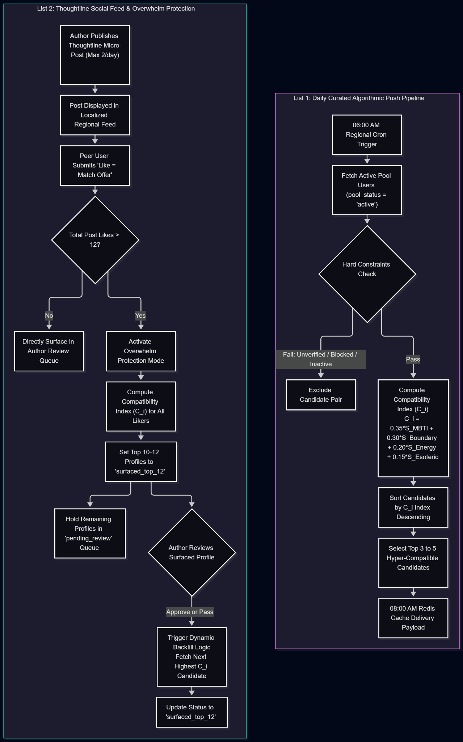

Figure 7.2 Callout Notes on Matching Pipeline Design:
- List 1 Isolation: Executes offline during low-traffic batch windows (06:00 AM), storing fixed payload vectors in Redis to eliminate real-time recommendation latency.
- List 2 Protection Loophole Fix: Overwhelm Protection dynamically gates inbound likes, capping cognitive load by ensuring post authors never evaluate more than 12 active candidates simultaneously.

3. Capacity, 1:1 Parity & Rotational Lifecycle State Machine
The state diagram below documents the formal state machine governing user pool progression, capacity queues, 72-hour active windows, and 14-day rotational cooldowns:
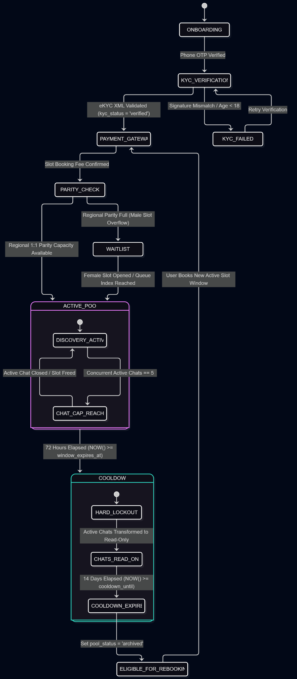

Figure 7.4 Journey Callout Notes:
- Intent Gate Protection: Direct messaging is strictly unreachable prior to step 36. Unauthorized message payload dispatches at the API Gateway level return standard HTTP 403 Forbidden status codes.
- Icebreaker Pre-Population: Upon quiz completion, quiz answer comparisons automatically render in the WebSocket chat history as structural icebreakers, removing initial message generation friction.

5. Database Entity-Relationship Diagram (ERD)
The ERD below illustrates the core data model schema, primary and foreign key constraints, data types, and cardinalities across persistent entity tables:
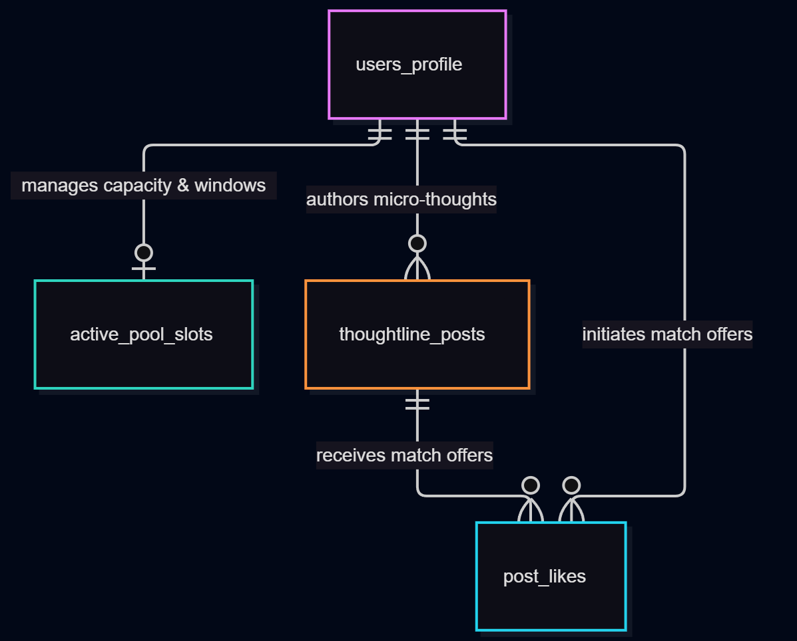

Figure 7.5 Entity Schema Notes:
- Indexing Strategy: B-Tree indexes are applied to user_id, city_partition, kyc_status, pool_status, and window_expires_at. GIN indexes are instantiated on dynamic_boundaries JSONB payloads for fast scalar filtering.
- Referential Integrity: Foreign keys enforce ON DELETE CASCADE on active_pool_slots, thoughtline_posts, and post_likes to guarantee clean account removal during user deletion routines.

6. AI Wingman Boundary Conflict & Safety Flowchart
The logic chart below details the runtime algorithmic evaluation of user dynamic boundary state vectors, parameter delta calculation, threshold evaluation, and safety banner injection:
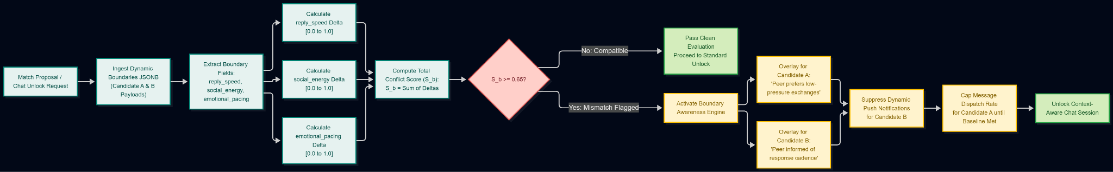

Figure 7.6 Safety Flowchart Notes:
- Delta Scaling: Distance metrics between ordinal boundary states (e.g., immediate vs. slow_replies_preferred) are normalized using calibrated scalar matrices stored in configuration memory.
Non-Punitive Design: A high Boundary Conflict Score (S_b >= 0.65) never cancels a structural match. Instead, it alters system delivery parameters to protect vulnerable communication states.

Metadata Field | Document Specification Details
Document Title | EqualSpace (v1.0) Product & Engineering Specification Document
Document Type | Technical Architecture & Engineering Specification
Version & Status | v1.0 — Production Ready Specification
Author / Owner | EqualSpace Engineering & Product Core Architecture Team
Target Systems | PostgreSQL (JSONB), Redis Enterprise, DigiLocker Meri Pehchaan API (v2.4)
Target Audience | Backend Engineering, Infrastructure Engineers, Product Operations

